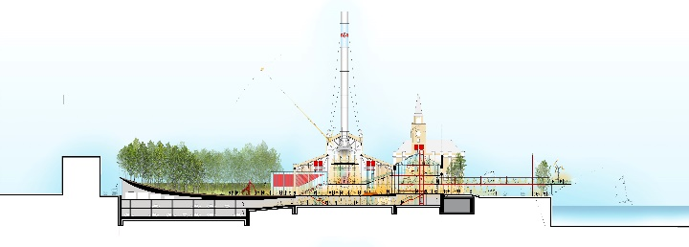 | Cross Section through the site  ©RPBW
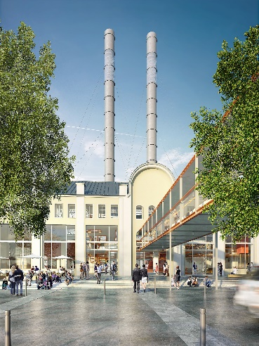 | Rendering View of the Entrance Piazza  ©RPBW
GES2_INTERIOR_NEWRENDERING | Rendering View of the Centrale Nave  ©RPBW
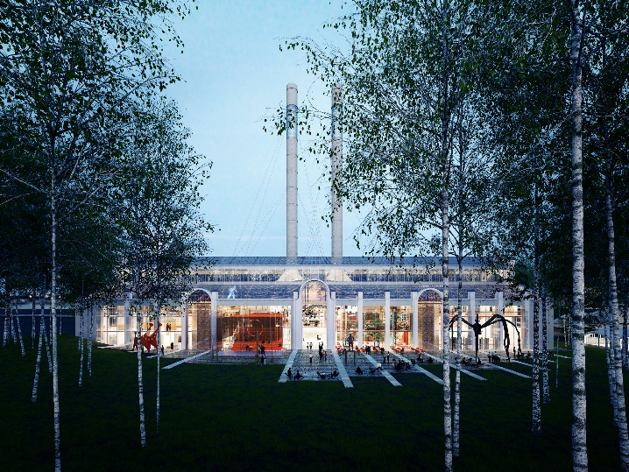 | Rendering View of the Building from the Birch Forest  ©RPBW
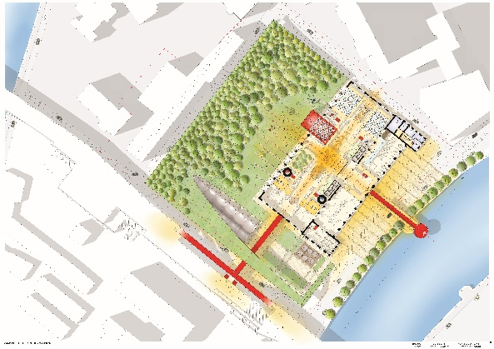 | Site Plan  ©RPBW
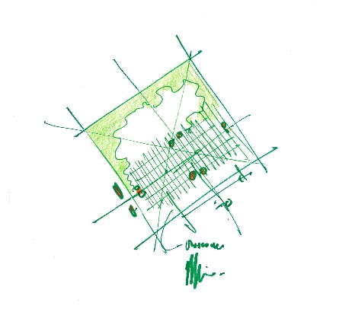 | Site Plan Sketch  ©RPBW
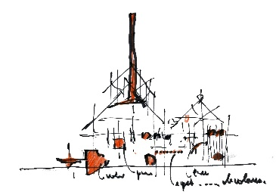 | Section Sketch  ©RPBW
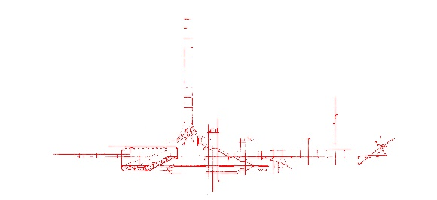 | Diagramme of the web  ©RPBW

